Indian School Al Wadi Al Kabir
Post midterm Practical Examination Worksheet
Computer Science

Class: VI Time: 45Mintues
Note book: 5 marks Max. Marks: 20

- Write a HTML code to given Output.
- In this output HR tag is used to draw line with attributes of align, size and color
- Background color and text color is changed.
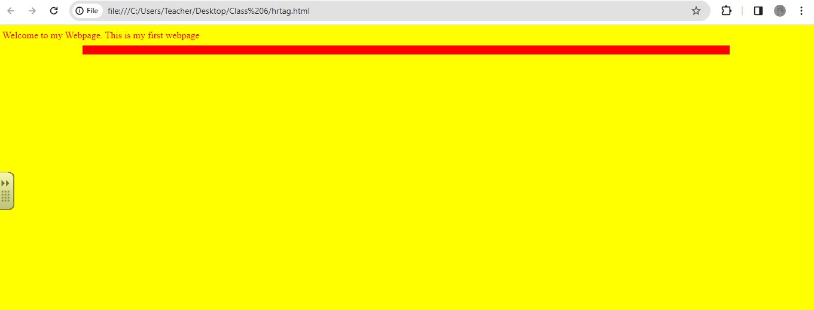
Ans.
<HTML>
<HEAD>
<TITLE> HORIZONTAL RULER</TITLE>
</HEAD>
<BODY bgcolor=yellow text=RED>
Welcome to my Webpage. This is my first webpage
<hr width=80% color=red align=center size=15>
</BODY>
</HTML>
- Create a HTML webpage using different Heading Tags<H1>…..<H6>
<html>
<head>
<title> Formatting tags</title>
</head>
<body BGCOLOR=BLUE TEXT=WHITE>
<h1> Used for Document Heading H1 </h1><br>
<h2> Used for page heading H2 </h2><br>
<h3> Used for Paragraph heading H3 </h3><br>
<h4>Used for sub heading tag for H4 </h4><br>
<h5> Used for topic heading tag for H5 </h5><br>
<h6>This is the least heading tag </h6><br>
</body>
</html>

- Write a HTML code for given output using Paragraph and break tag
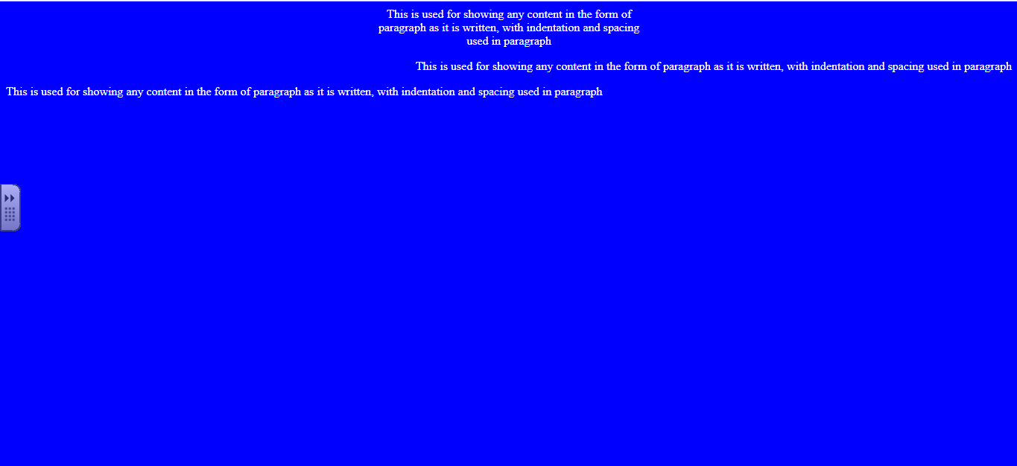
<html>
<head><title> Formatting tags</title></head>
<body bgcolor=blue text=white>
<p align=center>
This is used for showing any content in the form of <br>
paragraph as it is written, with indentation and spacing <br>
used in paragraph
</p>
<p align=right>
This is used for showing any content in the form of paragraph as it is written, with indentation and spacing used in paragraph
</p>
<p align= left>
This is used for showing any content in the form of paragraph as it is written, with indentation and spacing used in paragraph</p>
</body></html>

